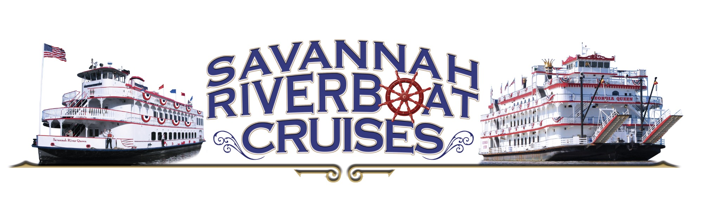
4th of July Dockside Dinner Celebration
An All-American Feast on the Waterfront

From the Grill & Smokehouse
• Independence Day BBQ Ribs – Slow-smoked with bourbon BBQ glaze
• Firecracker Jalapeño Cheddar Bratwurst
• Southern Fried Chicken
• All-American Grilled Chicken
• Lowcountry Pulled Pork
• Savannah BBQ Shrimp

Classic Cookout Sides
• Smoky Baked Beans
• Buttered Corn on the Cob
• Creamy Mac & Cheese
• Homestyle Potato Salad
• Southern Coleslaw
• Braised Collard Greens
• Fresh Garden Salad
• Watermelon & Seasonal Fruit
• Warm Buttermilk Biscuits

Stars & Sweets Dessert Bar
• All-American Apple Pie
• Strawberry Shortcake
• Assorted Cookies
• Loaded Chocolate Brownies
• Ice Cream Sundae Station

Celebrate freedom, flavor, and fireworks on the Savannah River.

